1 Maze solver
The program loads the maze image, converts it into a 21 x 21 grid, asks the user for an approach, solves the maze and shows every square it visited.
a) Storing and displaying the maze
I read the image with plt.imread. The image is 210 x 210 pixels, so each maze square is 10 x 10 pixels. For each square I check the brightness of its middle pixel: below 0.5 is a wall (1), otherwise a path (0).
The maze is stored as a list of lists, one list per row. This means maze[row][col] gives the value of any square directly. I print it in the terminal with ## for walls and two spaces for paths, so every square is two characters wide.
The entrance and exit are the path squares on the outer edge. The program finds them at (row 0, column 9) and (row 20, column 11).
[Screenshot: maze printed in the terminal]
b) Choosing the approach
The program asks the user to type backtracking or las vegas. A while loop keeps asking until the answer is valid. I convert the input with .lower().strip(), so capital letters and extra spaces are accepted.
[Screenshot: invalid input rejected, then a valid choice accepted]
b.i) Las Vegas approach
At each step the program lists every neighbouring square (up, down, left, right) that is inside the grid and is not a wall. It picks one at random with random.choice. It does not step straight back to the square it just came from unless that is the only option, which happens at a dead end.
The run ends when the exit is reached (successful) or after 200 steps (unsuccessful).
b.ii) Backtracking approach
Rationale for choosing a direction. At each square the program tries directions in a fixed order: down, right, left, up. Down comes first because the entrance is at the top and the exit is at the bottom. Right comes before left because the exit (column 11) is slightly right of the entrance (column 9). Up comes last because it usually leads back towards the entrance.
How the backtracking works. The current route is stored in a list called path, used as a stack. The program moves to the first direction in its order that is inside the grid, is not a wall and has not been visited, and adds that square to the end of path. If no direction works, it is at a dead end, so it removes the last square with path.pop(). This returns it to the previous square, where it tries the remaining directions.
A separate visited list stops it exploring any square twice, so it cannot go round in circles. If path becomes empty, every route has been tried and there is no solution.
On this maze, backtracking reaches the exit after visiting 75 squares. The shortest route is 62 steps.
c) Visualising the visited squares
When a run ends, successful or not, show_visited draws the maze with plt.imshow. Walls are black, unvisited paths white, visited squares yellow, the entrance green and the exit red.
[Screenshot: Las Vegas successful run]
[Screenshot: Las Vegas failed run]
[Screenshot: Backtracking run]

Error 1.
What went wrong: I was trying to print the maze to terminal. The maze printed as a long shaped instead of the 21 by 21 grid.
Fix: my print(line) was inside the column loop, so it ran 21 times per row instead of just once. This needed to fixed else every function depending on this output will be wrong. Identing properly fixed this bug.

s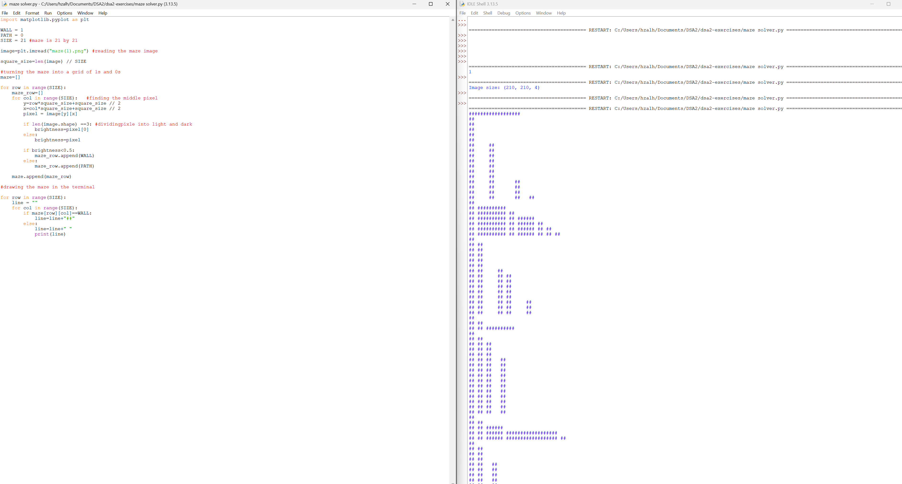

2nd error
What went wrong: after fixing the first error and running the code again. The below exhibit is seen. The corridors are not aligned
Fix: the path string was one space but the wall string was twp characters so the squares had different widths. I changed the path to two spaces and they became squares again.

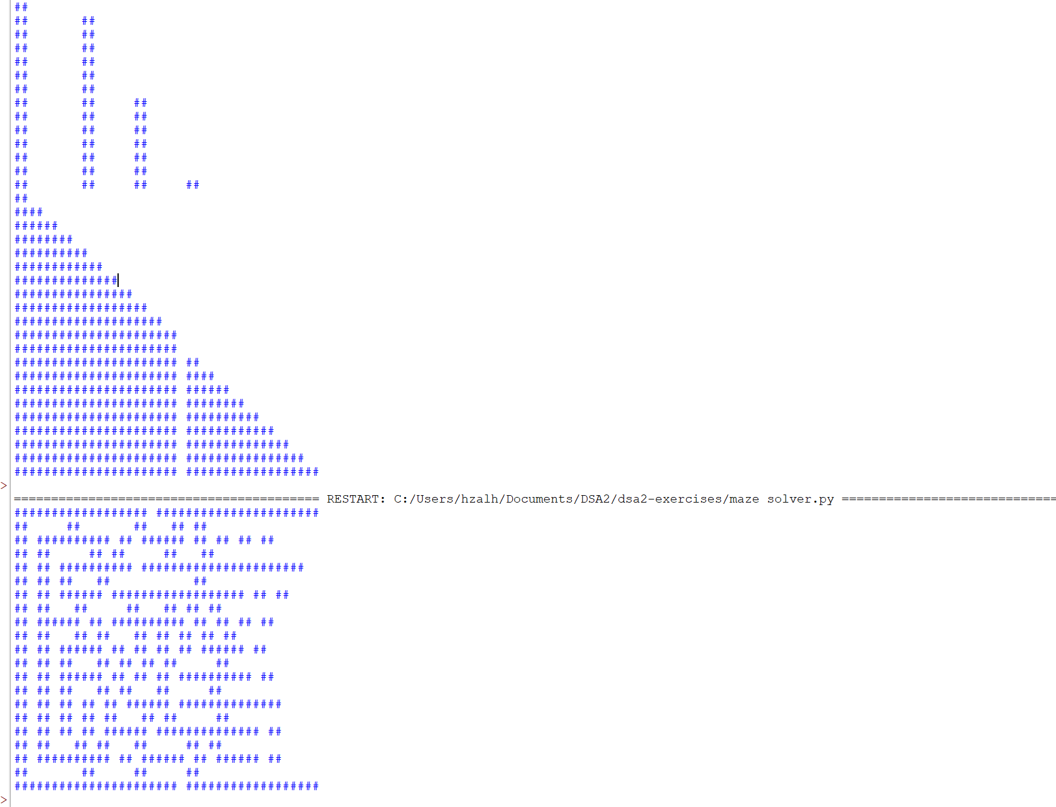

Fixed code

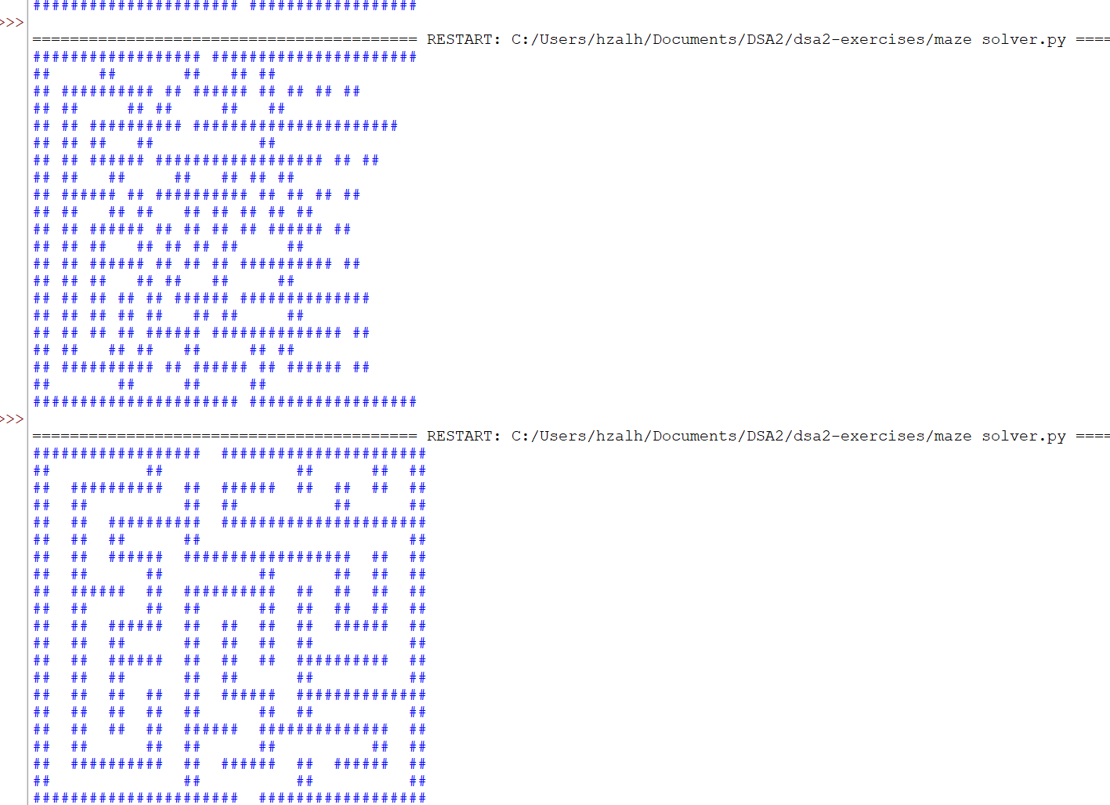

3rd bug
What went wrong : Las vegas approach never found the exit after 1000 runs. Increasing this to 10000 runs didn’t make a difference.
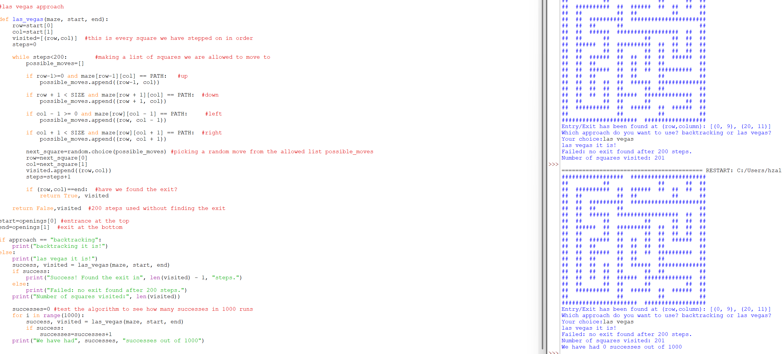

Fix: it seem when picking random direction from the allowed list, we often went backwards to the square we were just at. I have added a two lines that say don’t go straight back unless it is the only way. It has increased our success rate.

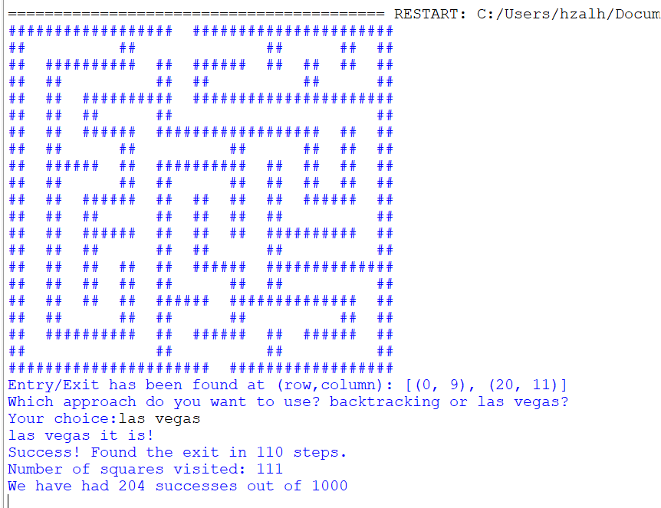

4th error

What went wrong: after the user chose backtracking, the program printed “backtracking it is!” and then stopped. The solver never ran and no picture was shown.

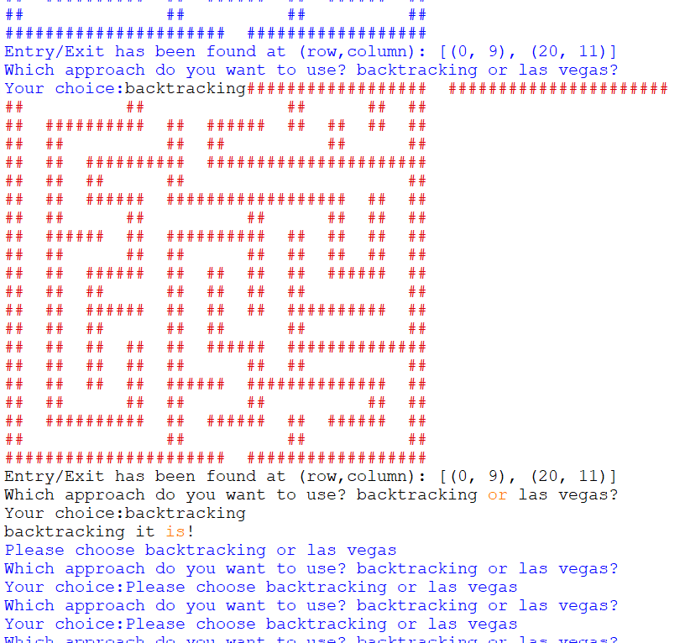

Fix and why it mattered: the code that runs the solvers was placed before the functions were defined. Python runs a file from top to bottom, so a function has to be defined before the code that calls it. Moving the running section to the end of the file fixed it. This mattered because the backtracking approach (b.ii) and the visualisation (c) were never actually being used

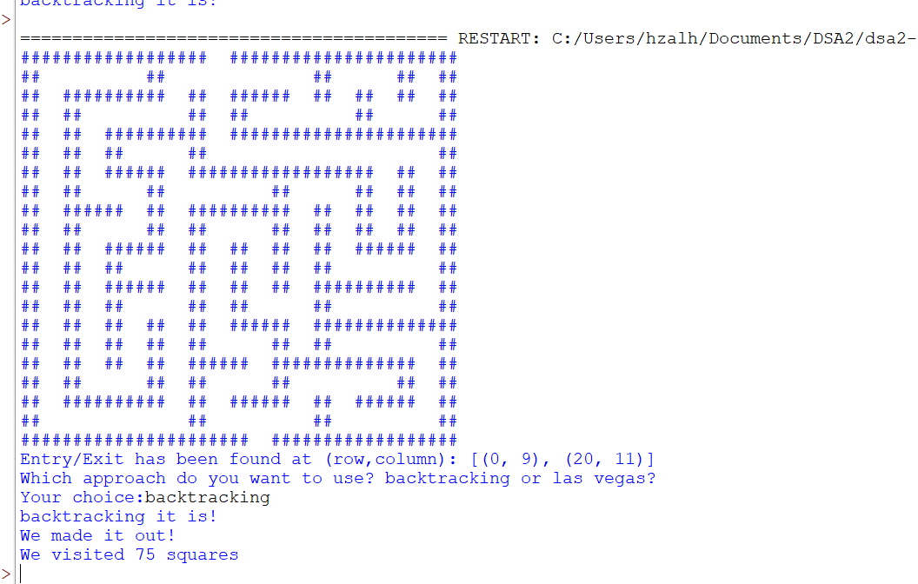

Completed Maze solver



